

Add New Leave Record
Make sure you have completed following session(s)
- None

For modifying large scale of employees’ leave taking at a time

Steps
- Press “Commander”
- Choose New Leave Taking
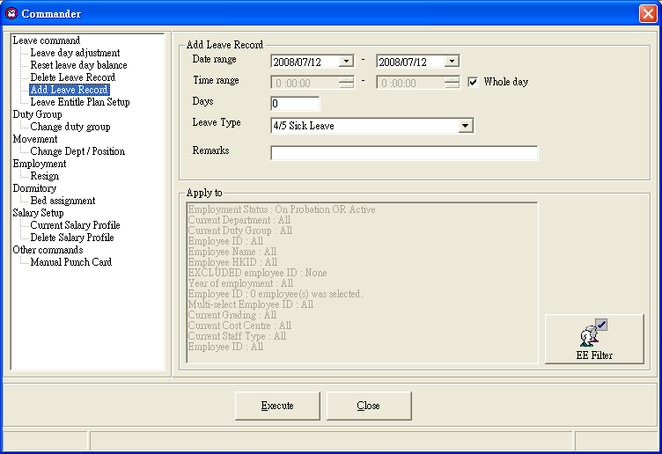

- Fill information :
“Date Range”, “Time range” (Or select “Whole day”), “Days” and “Leave Type”
Press “EE Filter” to choose suitable employee
Press “Execute” to start execute。

See also

